Forster, Bevan
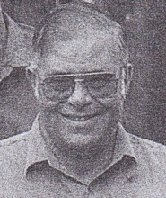
Graduated from the old Dwellingup Training school in 1960. Appointed Forest Guard in 1961. Transferred from Mundaring to Dwellingup in 1970. District Operations Officer in Kirup, Blackwood District 2001.

